FOUND
FOUND

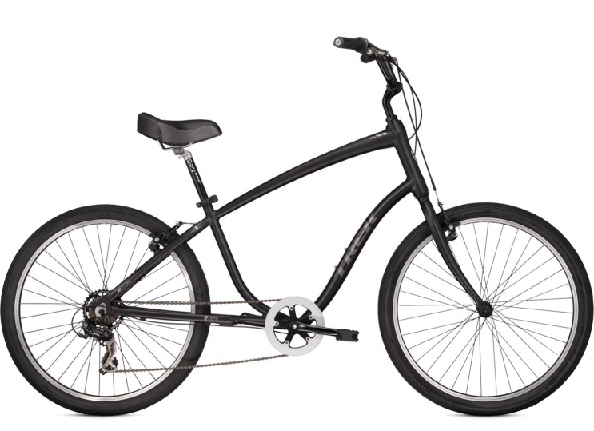
Mountain Bike

(not actual picture)

at
All Saints Church
Compton
Leek

If you think this is your mountain bike, please contact
the Parish Office on 01538 528545
(with a full description of it)

